The Impact of Global Events on the Film Industry (2000–2024)

A data-driven story of growth, collapse, and change.

Julian Hinds

Global Box Office Revenue (2000–2024)

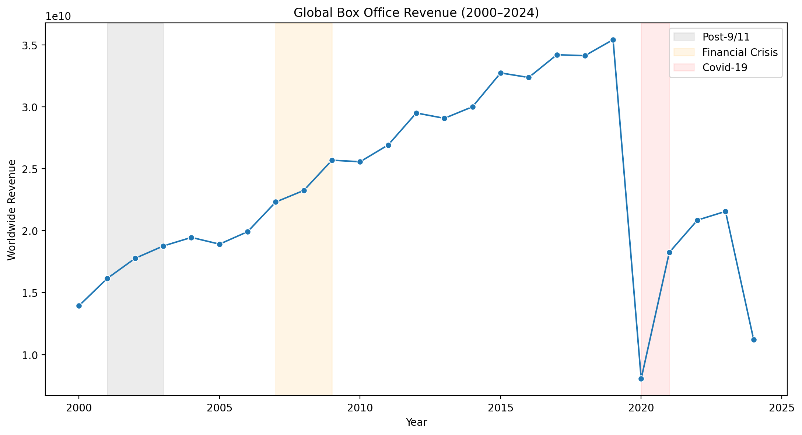

Hollywood’s Global Reality

By 2019, international audiences made up nearly 70% of box-office revenue.

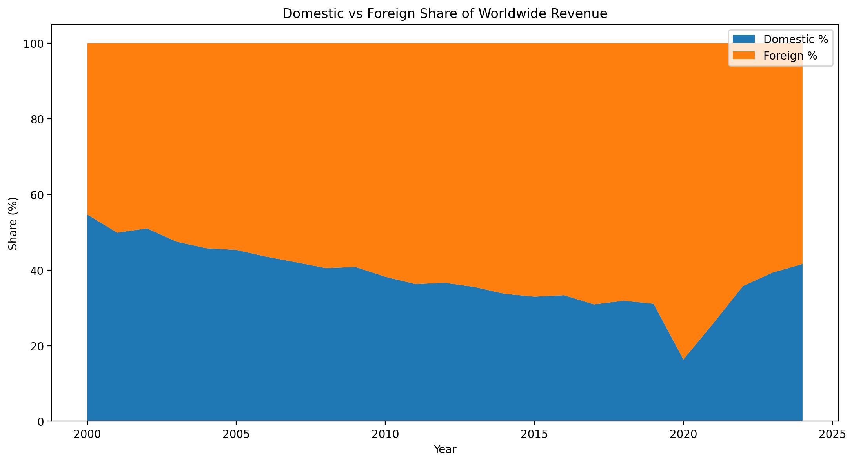

The ‘Wait-for-Streaming’ Effect

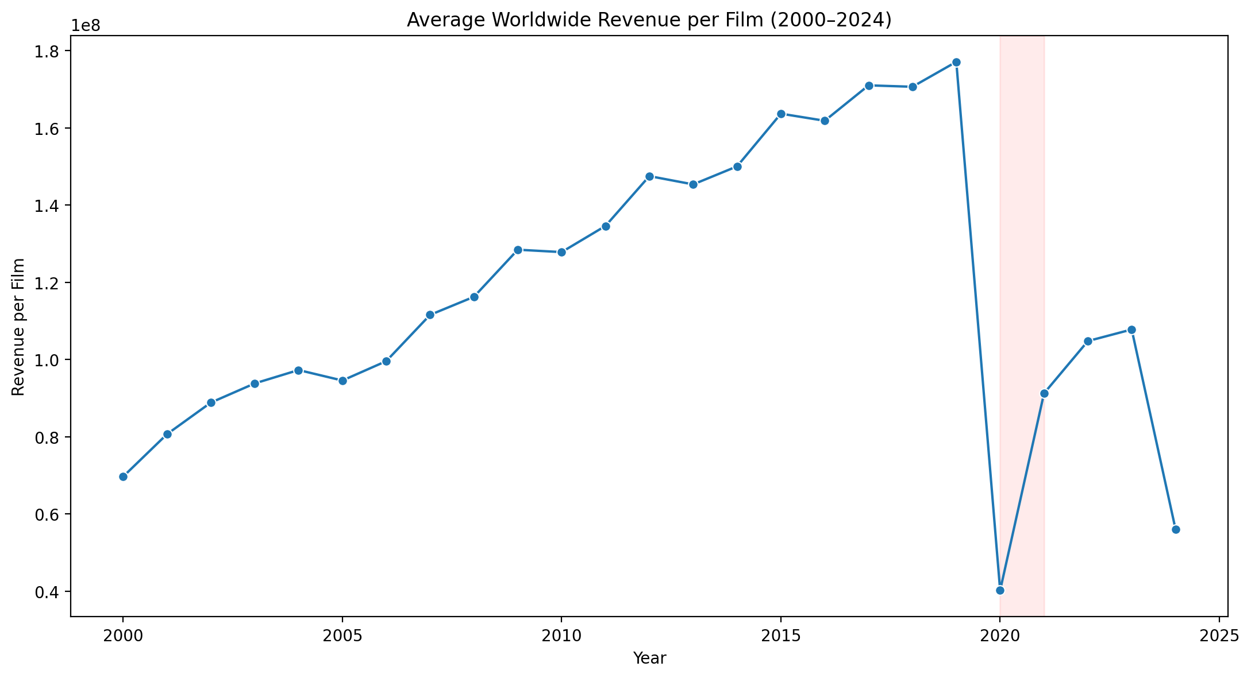

Recovery in numbers isn’t recovery in behaviour.  
*(Data source: Kaggle Box Office 2000–2024 | Tools: Python, Pandas, Matplotlib)*